***Venn Diagram Application***

***User Guide***

**TABLE OF CONTENTS**

**1 CONTACT**

**2 OVERVIEW**

**3 INSTALLATION INSTRUCTIONS**

**4 GETTING STARTED**

**4.1 After Opening The Application**

**5 COMMON USE CASES**

**5.1 Opening Application**

**5.2 Naming your Venn Diagram**

**5.3 Choosing the number of circles**

**5.4 Advanced Options**

**5.5 Selecting Font & Font size**

**5.6 Selecting Color**

**5.7 Confirming your Advanced Options**

**5.8 Creating your Venn Diagram**

**5.9 Venn Diagram Starting Screen**

**5.10 Inputting Data**

**5.11 After Inputting Data**

**5.12 The Legend**

**5.13 Changing the Name of a Circle**

**5.14 Viewing Statistical Breakdown**

**Contact:**

Alborz Gharabaghi 216442428

Kamal Patel 216280224

[kamalpatel291@gmail.com](mailto:kamalpatel291@gmail.com) (Installation Problems)

Tariq Qureshey 216789166

**Overview:**

This user-manual will be a complete coverage of all the common use cases for our application. They will include screen dumps of the application in use, to help clarify the use cases.

**Installation Instructions:**

To install our application, you must do the following:

1. Download the JAR file
2. Double click the JAR file to open the application

**Getting Started:**

1. **After Opening The Application:**

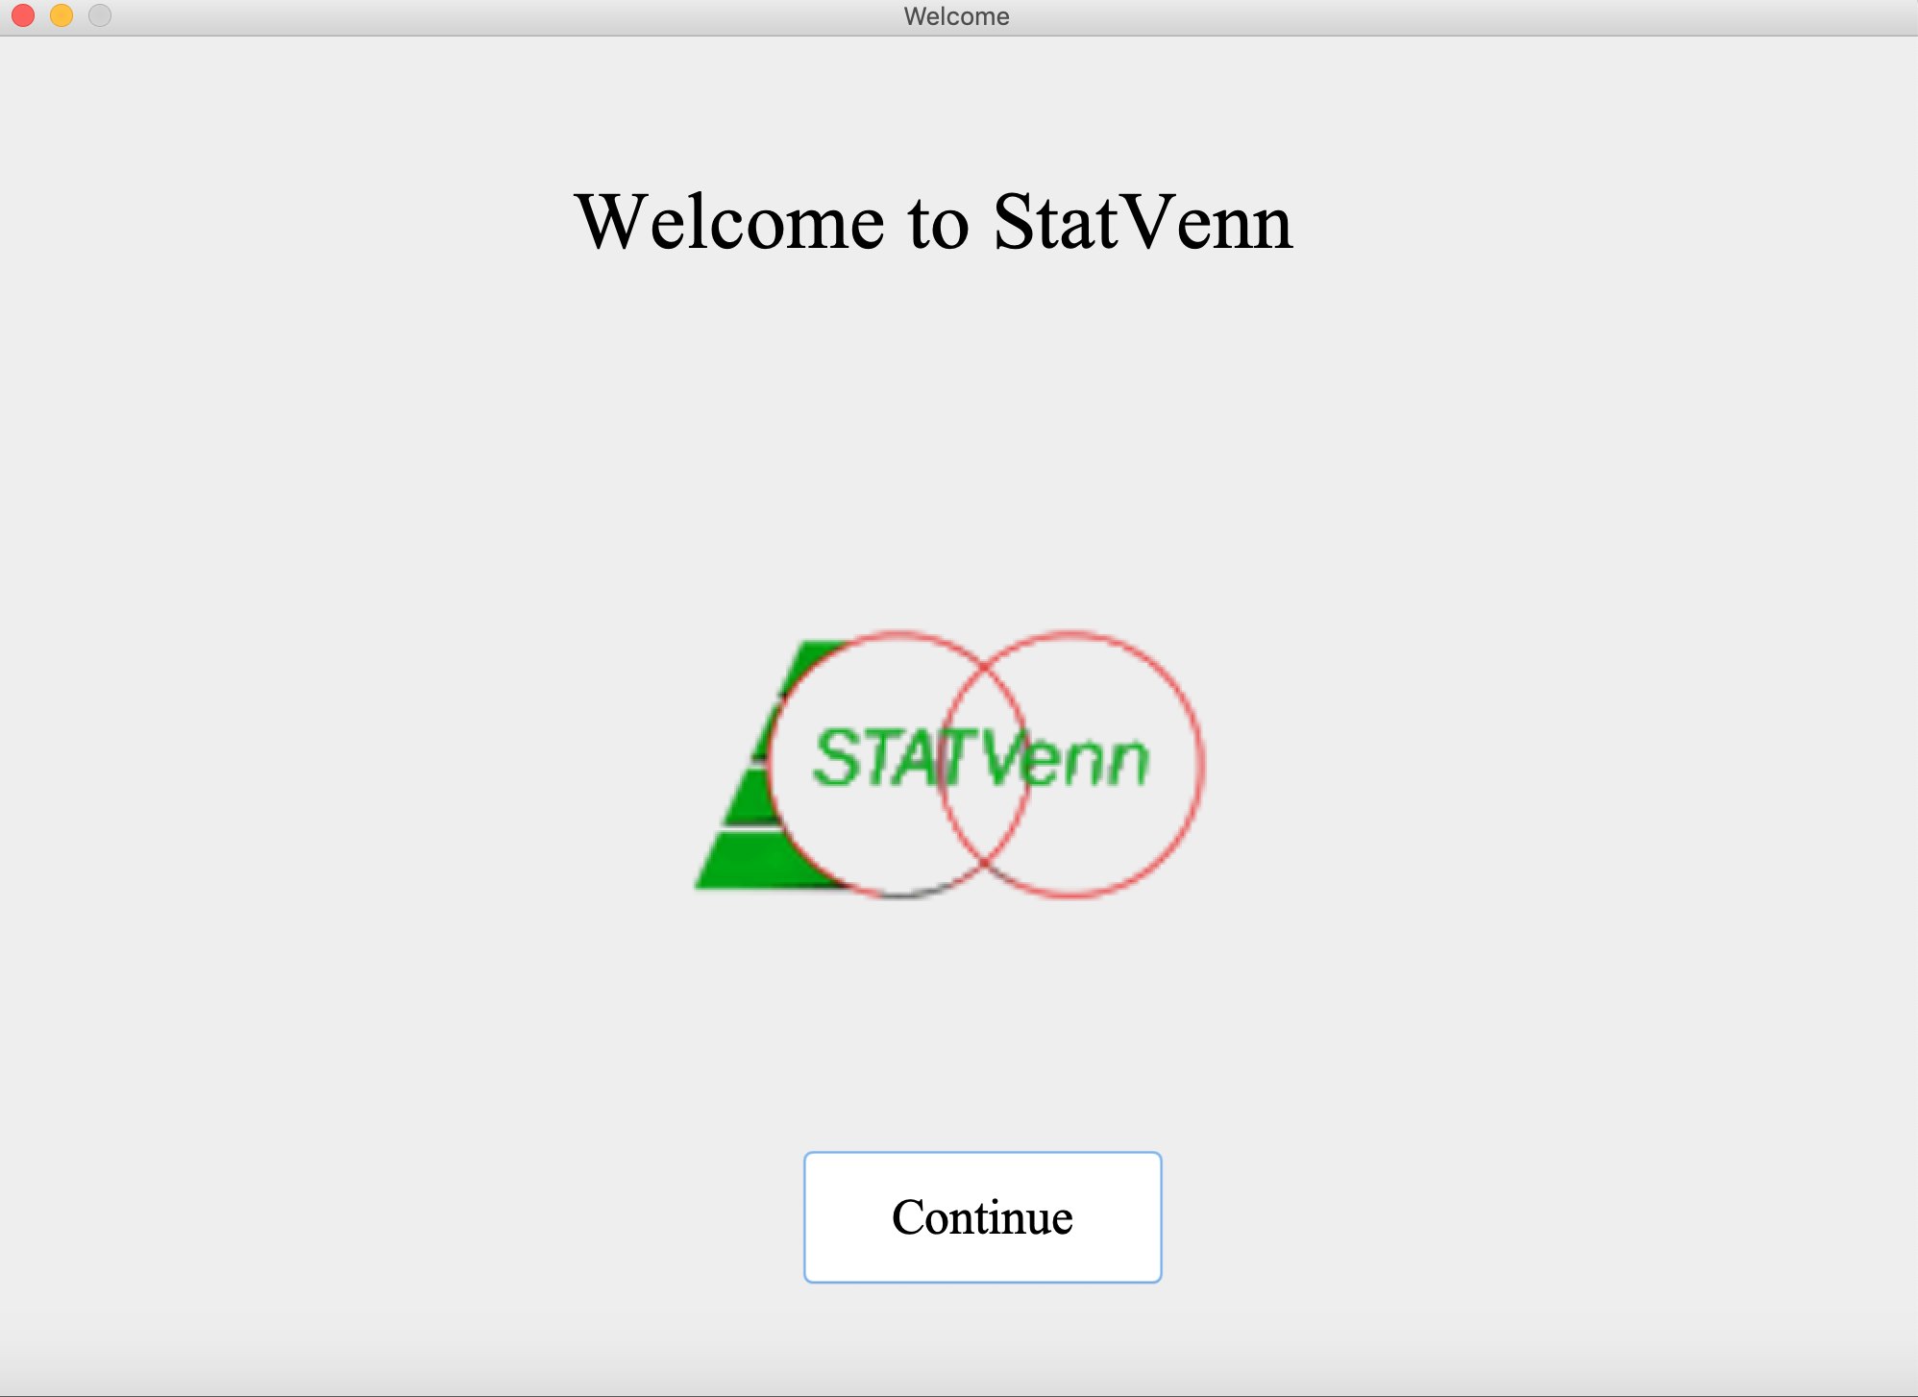

You will first be greeted with a message displaying “Welcome to StatVenn”. Press “Continue” to continue to the customize screen.

**On Mac:**

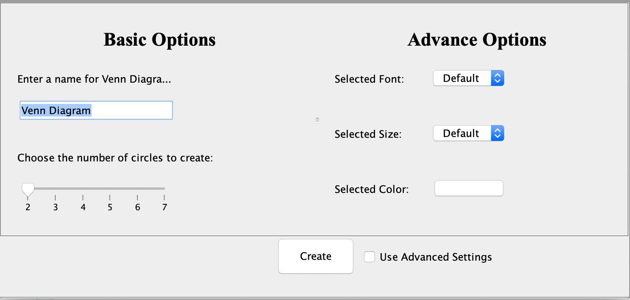

**On Windows:**

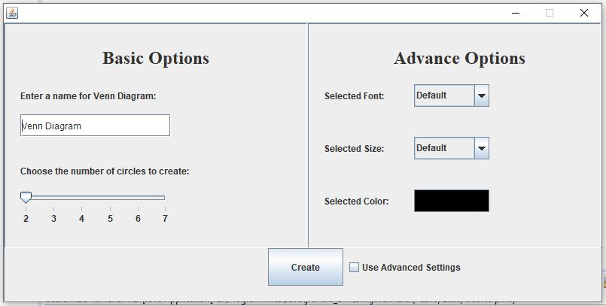

As you can see, the menu looks a little different on Mac than on Windows, for this manual, we will be using Mac. Here, you can customize your Venn diagram to your liking. These include choosing your own title, how many circles you would like and various other font options.

**Common Use Cases:**

1. **Naming your Venn diagram:**

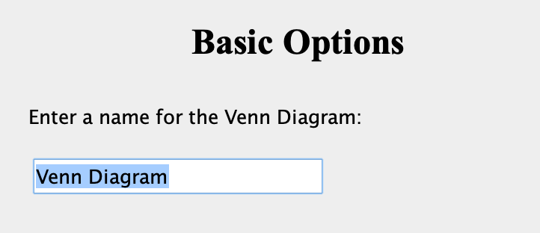

To name your Venn diagram, find the text box under “Basic Options” (as shown above), and begin typing to create your title.

1. **Choosing Number of Circles:**



To choose the numbers of circles to create, use the slider located in the bottom left of the frame. Currently, the program only supports the creation of 2 circles.

1. **Advanced Options:**

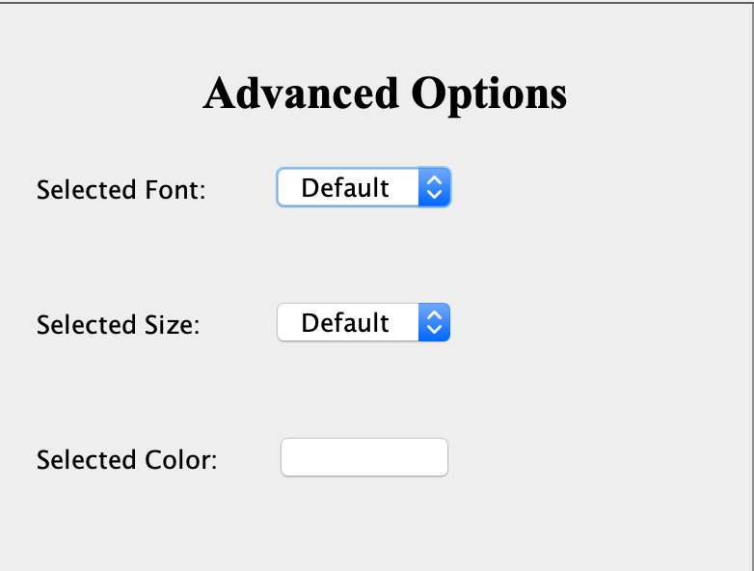

For customizing advanced options, there will be three drop-down menus to choose from. One that changes the font in your Venn diagram, another that changes the size of the font, and one that changes the color of the font.

1. **Selecting Font & Font Size:**

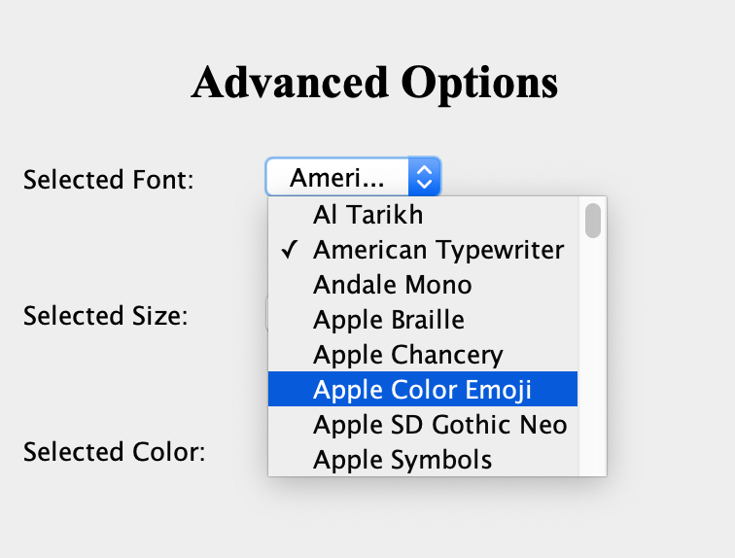

To select a font and its size, click on the corresponding dropdown menus, then click on your desired font/size. The default font is Arial, and the default size is 10.

1. **Selecting Color**

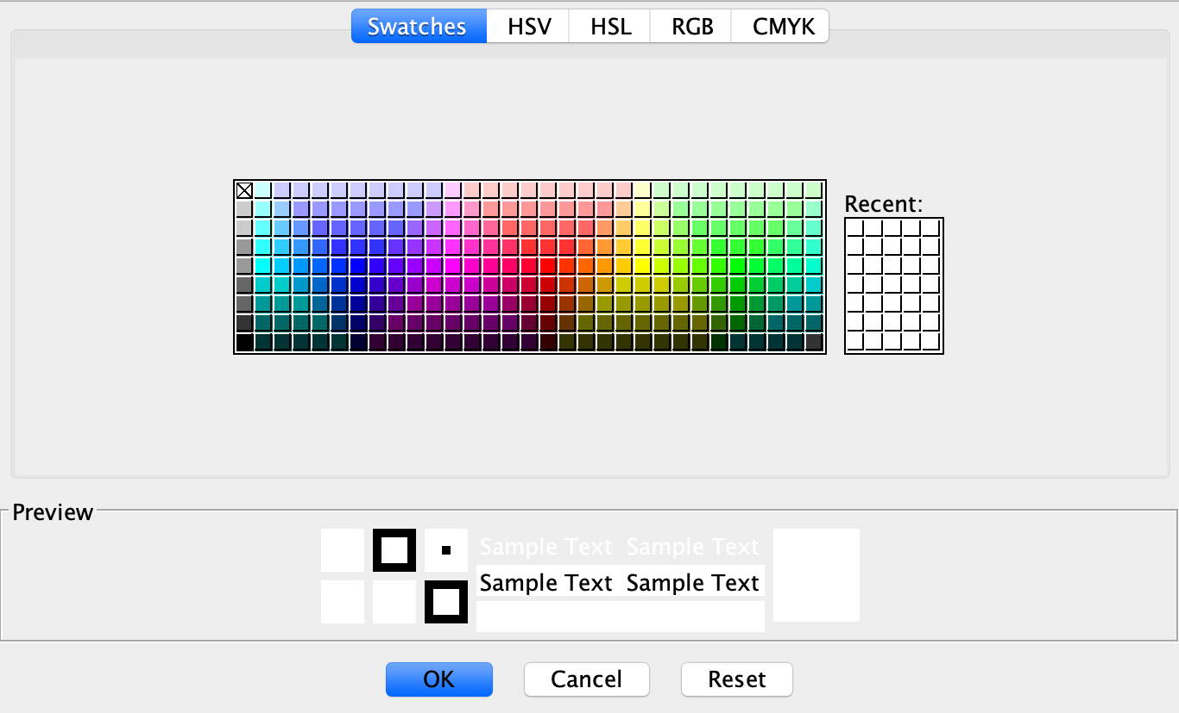

To select a color, click on the empty white box besides “Selected Color” and you will be greeted with the screen shown above. From here you can click on any of the shown colors to choose. The tabs at the top (“HSV”, “HSL” etc.) are just different ways of choosing a color.

1. **Confirming Your Advanced Options:**

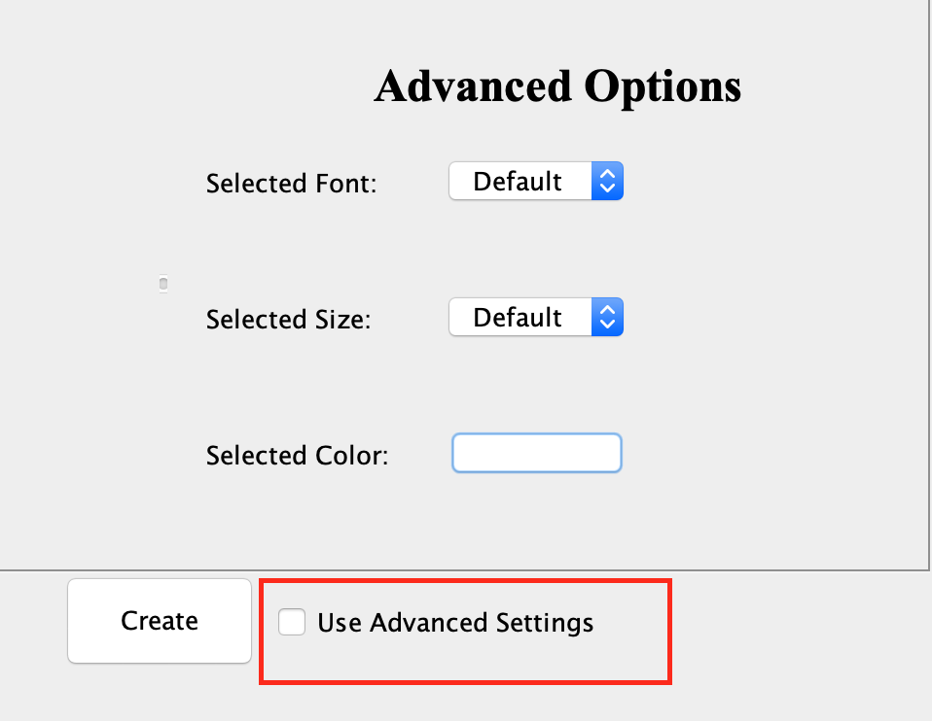

To make sure your font choices are saved, make sure to click on the “Use Advanced Settings” box!

1. **Creating Your Venn Diagram **NEW SCREEN SHOT PLEASE**

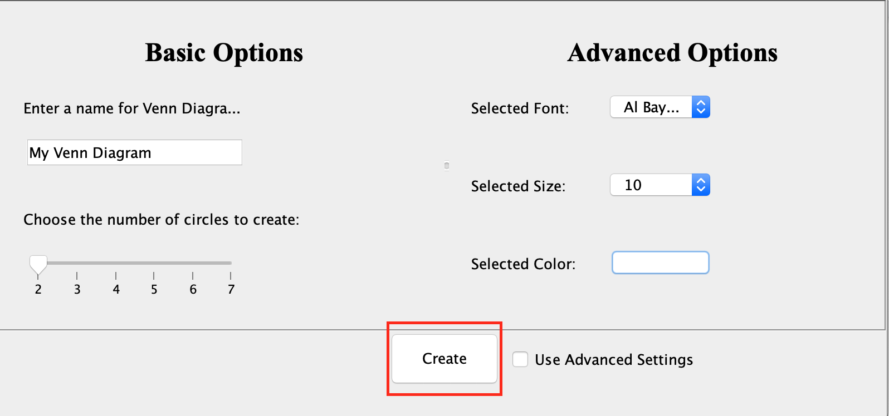

When you are finished personalizing your Venn diagram, you can select the “Create” button to create your Venn diagram!

1. **Venn Diagram Starting Screen**

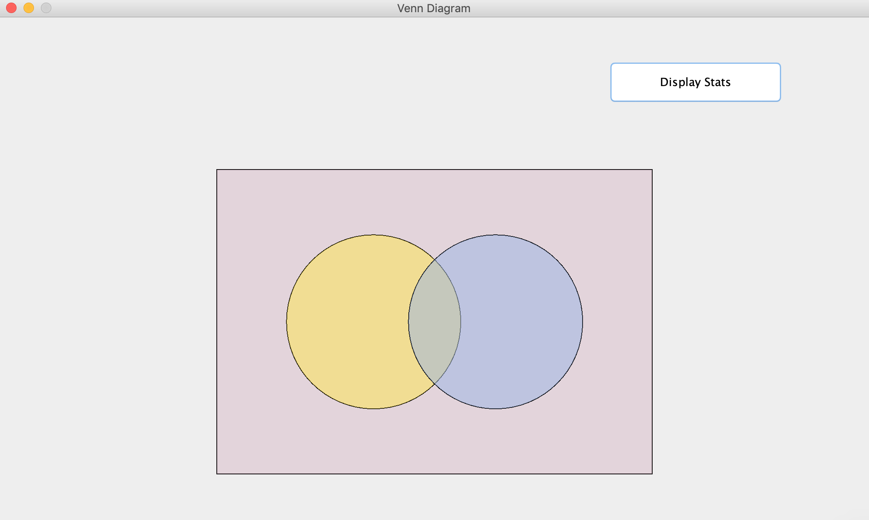

After you have clicked create on the previous frame, you will be greeted with a screen showing your Venn diagram. The large rectangle around the circles represents the sample space, inputting data into the rectangle and outside of the circles will add the to overall population as *not* a part of the circles. The display stats button will also display some statistical analysis based on the input inside of the Venn diagram at the time of entering data.

1. **Inputting Data**

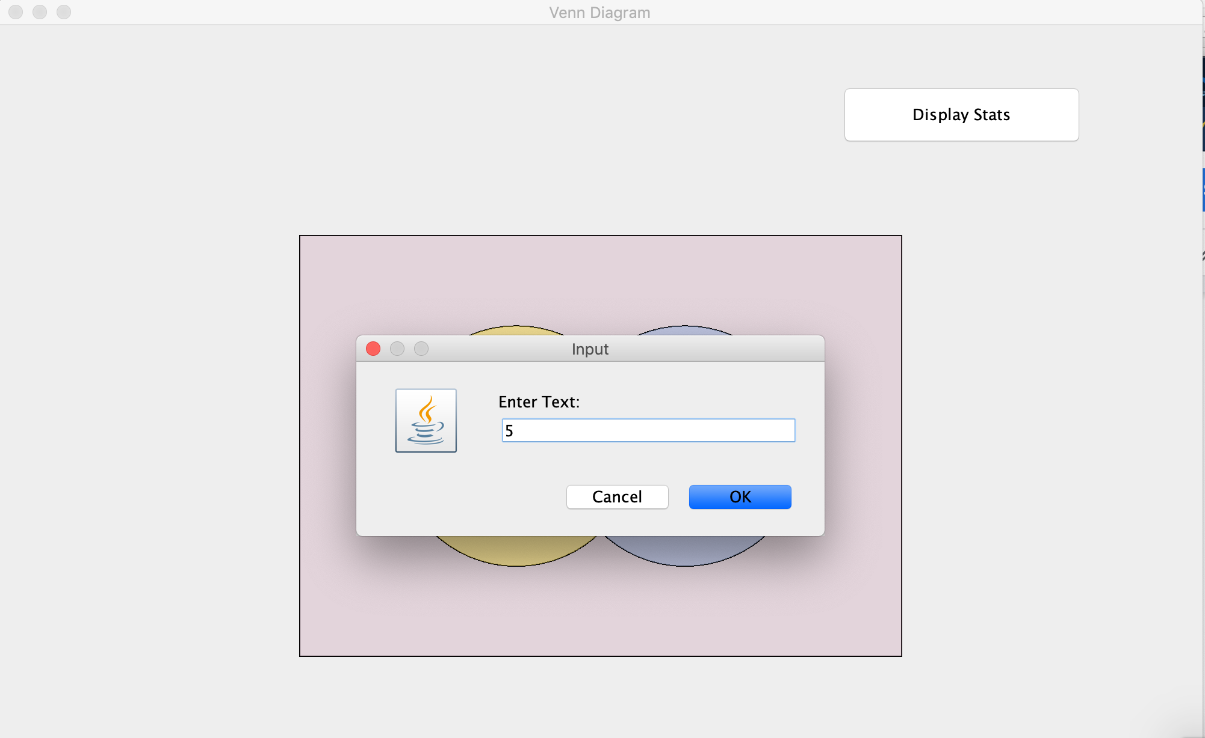

To input data, click anywhere inside the rectangle. You will then be greeted with an input box asking you to “Enter Text”. Start typing to write your desired numeric value into the input box. Pressing “Cancel” will make the input box disappear and you will return to the diagram screen. Pressing “OK” will confirm your choice and output your numeric value onto the Venn Diagram.

1. **After Inputting Data**

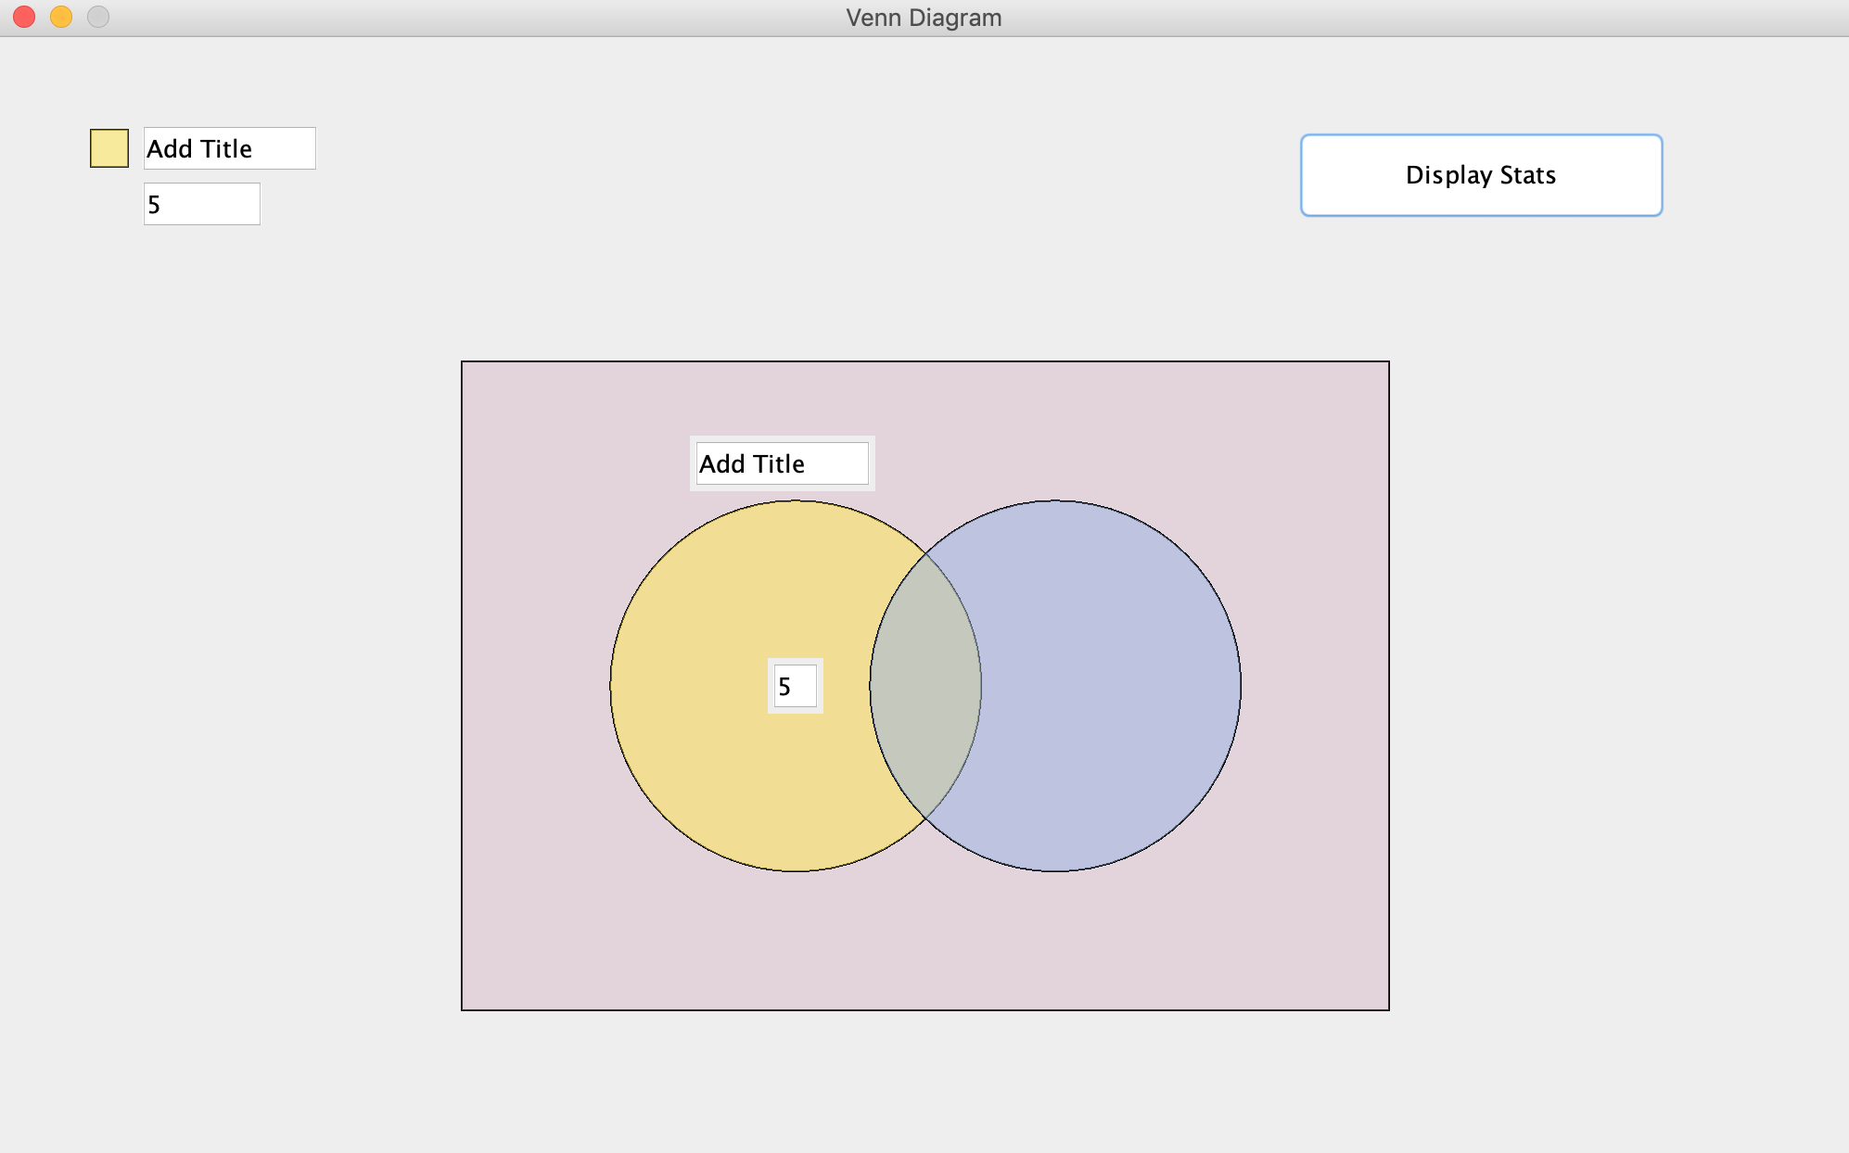

After you input your data into the Venn diagram (shown above, the number 5 was entered), your number will be outputted into the middle of the section you clicked on, along with a legend corresponding to the circle you clicked inside of (legends are only displayed for the main circles). Shown above, I clicked on the yellow circle to enter input into, so my input is now displayed inside of the yellow circle.

1. **The Legend**

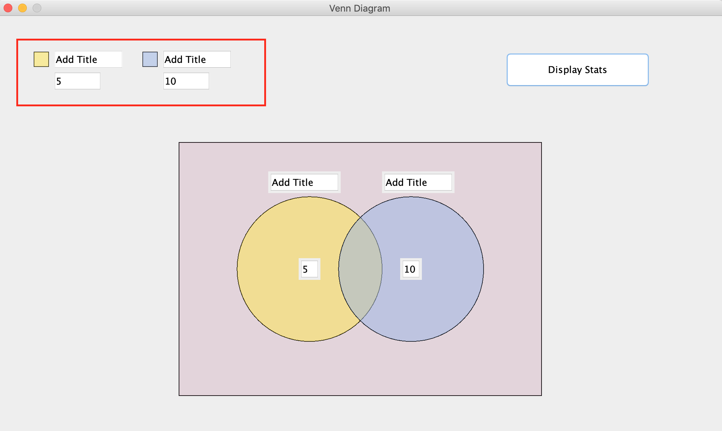

After entering data into a circle, a legend will appear above with a color code based on the circle you entered the data into. The data inside the circle is also shown, as well as a text field allowing you to change the title.

1. **Changing the Name of a Circle**

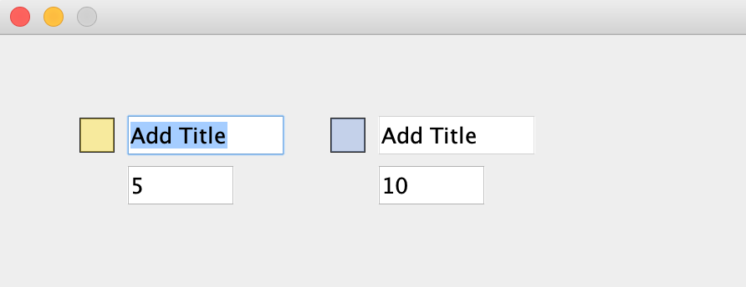(1) 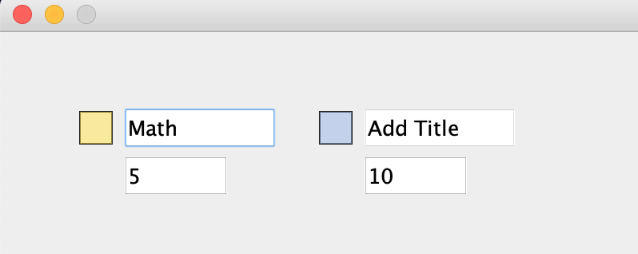(2)

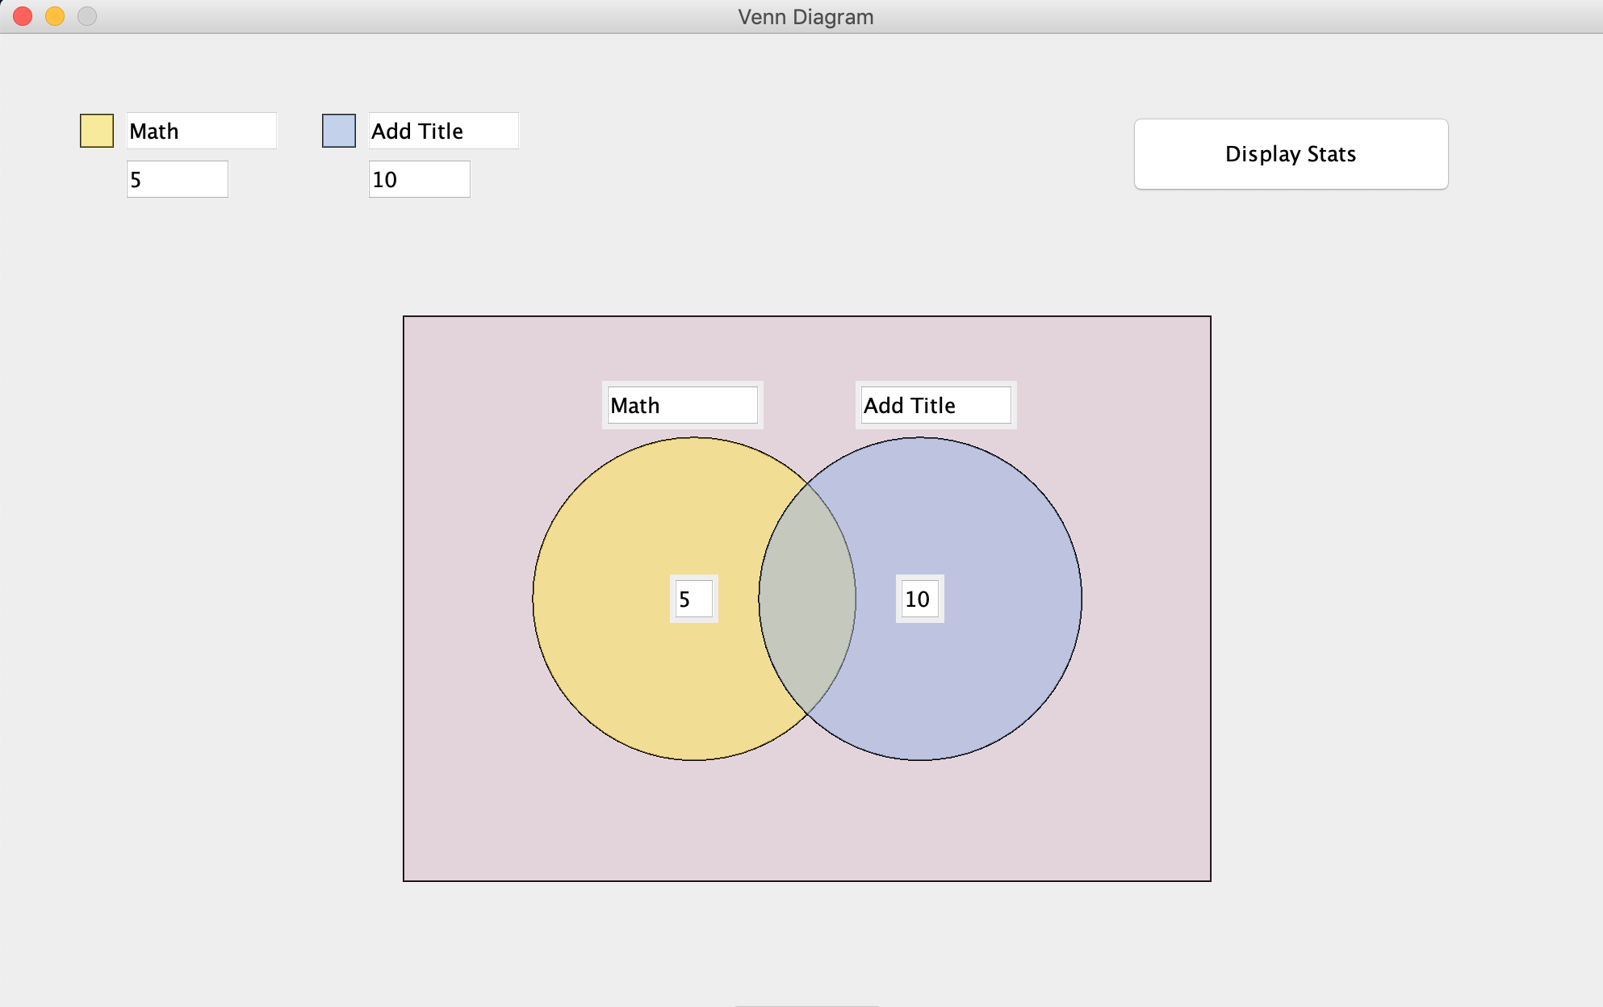(3)

To change the name of a circle, navigate to the legend of the circle you want to change the name of. Then, double or triple-click inside of the text field to highlight it (1). Next, click outside of the text field to finalize your decision (2). You will now be able to see the name you have just entered, above the corresponding circle and in the legend (3).

1. **Viewing Statistical Breakdown:**

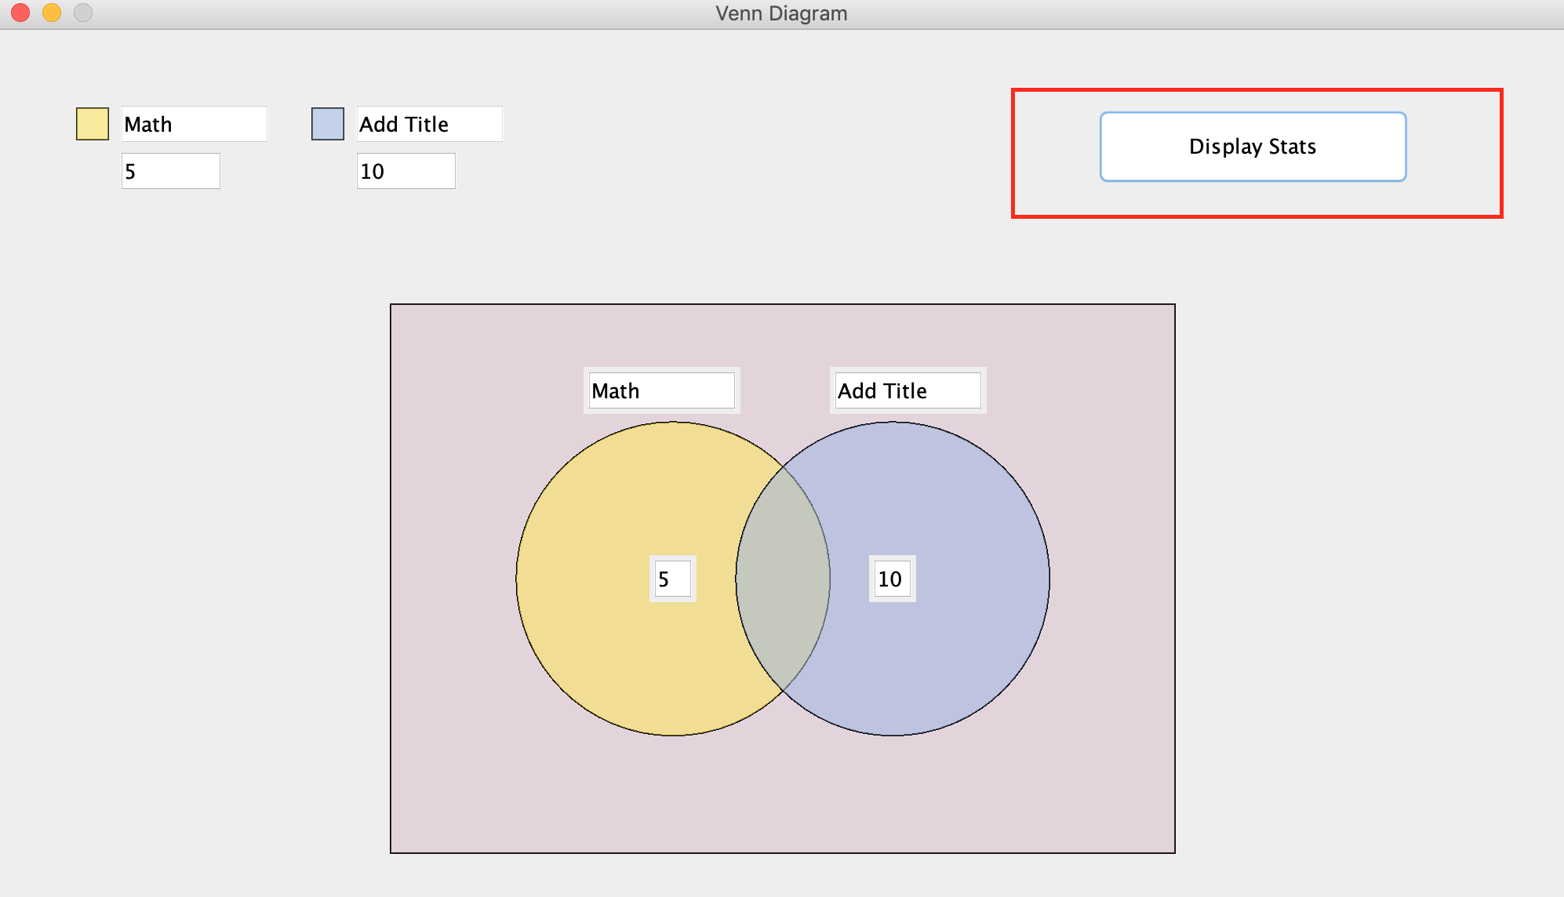**(1)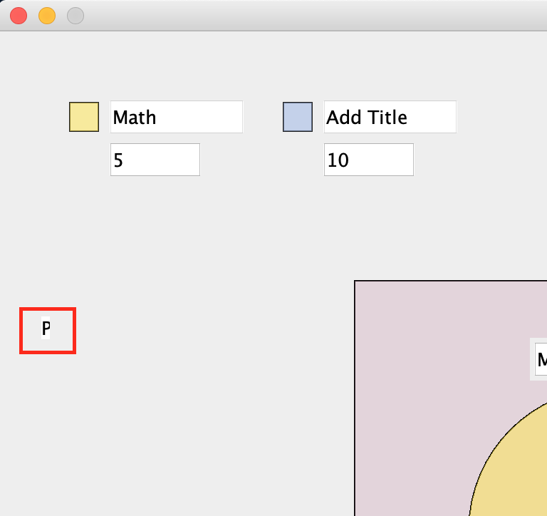(2)**

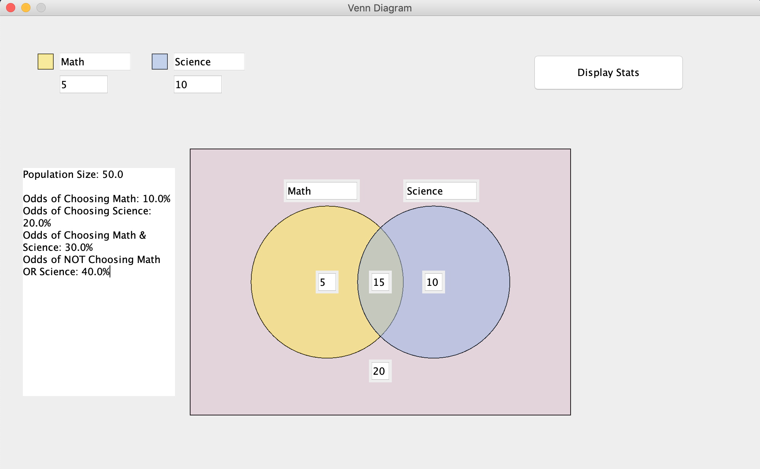**(3)**

To view a statistical breakdown of the data you have entered in the diagram so far, navigate to the “Display Stats” button (1) and click on it. After clicking on it, a small part of the text area will appear just below the legends (2), this is due to a bug at the moment of this user-manual but it is easily navigatable. You must click on the “P” shown in (2), and drag downwards and to the right to display the rest of the text area. Finally, you will see a text area showing useful statistics based on the input in the Venn diagram at the time of clicking the button (3). If you have changed the data after clicking the button, click it again to see the changes reflected in the text area.